Assessment in Physical Education (PE)

Informing Pupils of Targets:
- Following unit title pages in class PE evidence files, pupils have an outcomes target sheet which is shared with them at the beginning of each lesson.
- Pupils are guided to self-assess and peer-assess (where appropriate) against these targets in each lesson so that they are fully informed about their achievements, progress and next steps
- This ensures that pupils are accurately informed about the skills and knowledge they will be developing within every lesson and over time as part of a wider unit of work

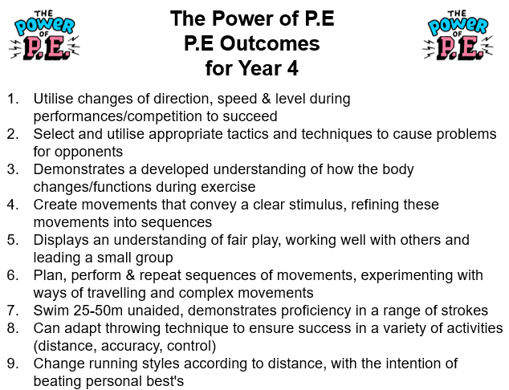

Ongoing Assessment:
- Class Teachers and HLTAs (where appropriate) use a range of Assessment for Learning strategies in order to formatively assess pupils’ achievements and progress within lessons.

Formal Assessment:
- Pupils’ achievements and progress is assessed formally by Class Teachers at the end of each unit of work (once per half term for both indoor and outdoor units of work).
- An assessment spreadsheet is used to minimise unnecessary workload and enable data to be automatically calculated.

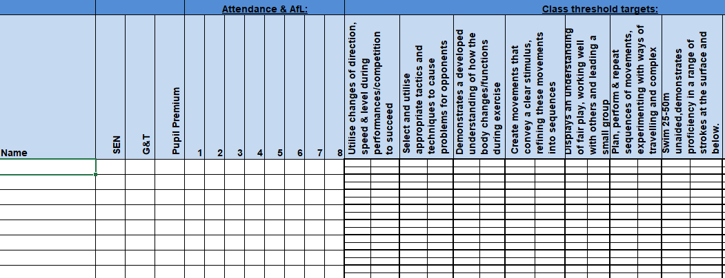

- Class Teachers can choose whether to update the spreadsheet at the end of each lesson or at the end of the unit of work
- The spreadsheet is updated using a different colour in each half term to track progress and show when progress against each statement was made

Aut 1
Aut 2
Spr 1
Spr 2
Sum 1
Sum 2

- The Assessment Tracker spreadsheet includes 4 cells for each pupil for each objective. These cells indicate whether a pupil is Working Towards ARE, Working at ARE and Working at Greater Depth
Working Towards ARE | 1 cell highlighted
Working at ARE | 2 cells highlighted
Working at Greater Depth | 3 cells highlighted
Exceptional  (e.g. representing county in a related event) | 4 cells highlighted

Assessing Physical Fitness:
- Each term, pupils complete the Bleep Test which assesses their physical fitness levels
- Results from the termly Bleep Test are recorded on an assessment spreadsheet and shared with the PE subject lead and members of SLT
- Pupils’ progress in the Bleep Test is monitored on an individual basis

Reporting and Tracking:
- Class Teachers share completed assessment spreadsheets with the Subject Leader and Curriculum Lead (DHT) at the end of each unit
- The data submitted is analysed by Leaders in order to identify trends and areas for further development

Moderation:
- Non-Core assessment data is reviewed termly by Subject Leads, the Curriculum Lead and SLT and is subject to internal moderation.
- Class teachers discuss the attainment and progress of pupils in all non-core subjects at termly Pupil Progress meetings with members of SLT.

